
Acquisition Management System Guidance

Post-Implementation Review Data Readiness Assessment Guidance

January 2020
Version 1.0

Table of Contents
1. What is the PDRA? 1
2. When are PDRAs performed? 1
3. Why are PDRAs performed? 2
4. Which investment programs are required to perform a PDRA? 2
5. Who conducts the PDRA? 2
6. How are PDRA results documented? 3
7. What is done with the PDRA results? 4
Appendix A: Acronyms 5

What is the PDRA?
The Post-Implementation Review Data Readiness Assessment (PDRA) is an assessment of the progress investment programs have made toward successful preparation to conduct a Post-Implementation Review (PIR).

When are PDRAs performed?
PDRAs are performed in accordance with the Agency-level PDRA schedule.

Figure 1 below depicts when PDRAs are conducted in the context of the phases of the acquisition lifecycle. PDRAs occur after the Final Investment Decision (FID) is achieved, during Solution Implementation, and prior to PIR conduct.

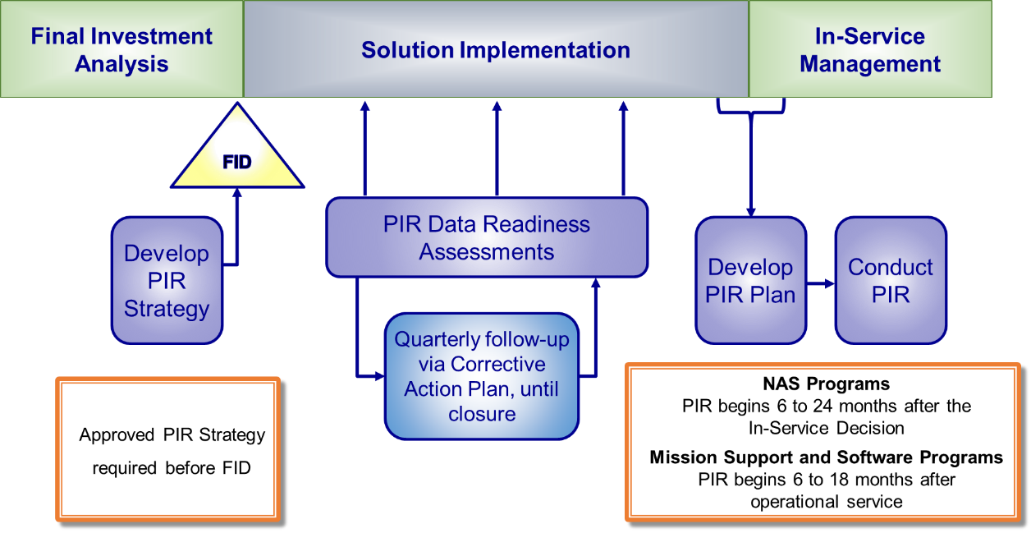

Figure 1. PDRA in the Acquisition Management System (AMS) lifecycle.

Why are PDRAs performed?
The PDRA process addresses deficiencies found in the conduct of previous PIRs in the areas of metrics development and data collection. PDRAs are performed to assess the progress that investment programs have made in developing and implementing their methodology for collecting data and information in preparation for an upcoming PIR. There must be confidence that the methodologies chosen to achieve the adopted measures are being implemented and are more than reasonable assumptions or theory.

At a minimum, the PDRA answers the following questions:
- Considering any change that may have been imposed on the investment program by changing requirements, budgets, or schedules, is the approved PIR strategy of the investment program still accurate?
- Are all the evaluation measures that are represented within that PIR strategy accurately described in terms of the data sources, data collection methods, and evaluation methods? Should the PIR strategy be updated to reflect changes in the investment program or the context of its mission?
- Does the investment program’s schedule of planned work activities include the work necessary to obtain, retain, and analyze the data identified in that PIR strategy?
- At the time of the PDRA, does the actual work completed to date, along with the schedule of planned work activities, support a timely completion of the PIR?
- Have resources for the data collection and analysis in support of the PIR been assigned, and is that associated work on schedule?

Which investment programs are required to perform a PDRA?
The PDRA process is applicable to all investment programs that have a Joint Resource Council (JRC) approved final investment decision (FID) and PIR strategy.

Who conducts the PDRA?
The PDRA is conducted in two parts; a self-assessment is conducted by the investment program and an independent assessment is conducted by the PIR Quality Officer or designee. The PIR Quality Officer or designee initiates the process by populating a portion of the draft PDRA report as described, prior to sending it to the investment program for completion of its self-assessment. Specific roles and responsibilities are described below.

The investment program:
- Conducts a self-assessment of the PIR strategy by answering the questions in Section 3 above, for each assessment area.
Note: The self-assessment is documented in Section 3.0 of the PDRA report template.
- Provides sample data for the measures in each assessment area, as applicable, to demonstrate data availability and suitability in preparation for the PIR.
- Identifies issues resulting from the conduct of the self-assessment for each assessment area.
- Works with the PIR Quality Officer or designee to develop a Corrective Action Plan, based on the findings and recommendations of the independent assessment.
- Provides quarterly status updates of all open actions on the Corrective Action Plan, until closure.

The PIR Quality Officer or designee:
- Develops a draft PDRA report, completing Section 1.0 and the first column of the tables in Section 3.0 of the PDRA report template, prior to sending it to the investment program.
- Conducts an independent assessment of the PIR strategy to determine whether:
- The measures in the PIR strategy are aligned with the objectives of the investment program, as baselined by the Joint Resources Council (JRC).
- The data sources, collection methods, and evaluation methods, as described in the PIR strategy, remain current or need to be updated.
- The planned PIR(s) documented in the PIR strategy will be completed according to schedule.
- Determines a status for each assessment area and the overall assessment.
- Develops findings and recommendations based on the independent assessment.
- Works with the investment program to develop a Corrective Action Plan, based on the findings and recommendations of the independent assessment.
- Solicits quarterly status updates from all investment programs with open actions on Corrective Action Plans, until closure.

How are PDRA results documented?
Using the latest version of the PDRA report template, the results are documented in a report for each investment program undergoing a PDRA.

The latest version of the PDRA report template can be obtained from the PIR portion of the JRC Process Information Portal at:
https://ksn2.faa.gov/afn/jrcportal/SitePages/PIR.aspx

What is done with the PDRA results?
The results of the PDRA are jointly approved by the PIR Quality Officer and the Program Manager of the investment program. The results of a PDRA may require an investment program to update its PIR strategy. The measures may also need to be revised, which could result in the business case being revised and approved by the JRC. Additionally, PDRA results are presented to the JRC during the PIR quarterly status reviews.

Appendix A: Acronyms

AMS Acquisition Management System
FID Final Investment Decision

IPM Investment Process Management

JRC Joint Resources Council

PDRA PIR Data Readiness Assessment
PIR Post-Implementation Review

