
Acquisition Management System Guidance

Test and Evaluation (T&E) Process Guidelines

7/10/2020, Version 1.0

Page intentionally left blank

TABLE OF CONTENTS
1 INTRODUCTION 1
2 AMS LIFECYCLE MANAGEMENT PROCESS 5
2.1 Test and Evaluation Support of Service Analysis and Strategic Planning/
Concept & Requirements Definition 7
2.2 Test and Evaluation Support of Investment Analysis 9
2.2.1 Program Requirements Document Support 9
2.2.2 Test and Evaluation Master Plan 10
2.2.3 Implementation Strategy and Planning Document Support 11
2.2.4 System Specification Support 11
2.2.5 SIR Support 11
2.2.6 Proposal Evaluation Support 12
2.3 Test and Evaluation Support of Solution Implementation 12
2.3.1 Development Testing 12
2.3.2 Operational Testing 13
2.3.3 Field Familiarization 15
2.3.4 Independent Operational Assessments 16
2.4 Test and Evaluation Support of In-Service Management 17
2.4.1 In-Service Management Test and Evaluation Master Plans 17
2.4.2 In-Service Management Developmental, Operational, and
Key-Site Testing 17
3 COMMON ELEMENTS FOR PERFORMING TEST and EVALUATION 19
3.1 Test Planning 19
3.1.1 Overall Test Approach 19
3.1.2 Develop Applicable Test Plans 19
3.1.3 Test Program Management 20
3.1.4 Define Entrance and Exit Criteria 20
3.1.5 Test Program Schedule 21
3.1.6 Develop and Maintain a Verification Requirements
Traceability Matrix 21
3.1.7 Test Capabilities 22
3.1.8 Test Personnel Resources 22
3.1.9 Develop Test Procedures 23
3.1.10 Problem Reporting 23
3.2 Test Conduct 24
3.2.1 Debug and Dry-Run Testing 24
3.2.2 Pre-Test Review 24
3.2.3 Final Test Execution 25
3.2.4 Post-Test Reviews 25
3.2.5 Regression Testing 26
3.3 Test Reporting 26
3.3.1 Early Evaluation Reporting 26
3.3.2 Preliminary Reporting 27
3.3.2.1 Interim Assessment Report 27
3.3.2.2 Quicklook Report 27
3.3.3 Final Reporting 28
3.4 Tailoring 29
APPENDIX A – ACRONYMS A-1
APPENDIX B – GLOSSARY B-1

LIST OF FIGURES
Figure 1-1: Link from T&E Policy to T&E Processes 1
Figure 1-2: T&E Application of the V-Model 2
Figure 2-1: Typical T&E Approach throughout the AMS Lifecycle 6
Figure 2-2: V&V for Decision Support 8
Figure 2-3: DT Activity Structure 13
Figure 2-4: Decomposition of Critical Operation Issues to Test Cases 14

INTRODUCTION
This Test and Evaluation (T&E) Process Guidelines document provides guidance for organizations executing the T&E Policy incorporated in the Federal Aviation Administration (FAA) Acquisition Management System (AMS) and the FAA AMS Lifecycle Verification and Validation (V&V) Guidelines.
The primary purpose of T&E is to provide decision authorities with the information needed for operational readiness, deployment, and in-service decisions. The guidelines in this document define key T&E elements that should be incorporated into T&E processes developed and maintained by program offices and in-service organizations to determine their ability to satisfy Agency needs throughout the AMS lifecycle.
Figure 1-1, Link from T&E Policy to T&E Processes, depicts that the T&E Process Guidelines provides the link from T&E requirements in the AMS Policy to T&E processes adopted by FAA organizations. These guidelines also provide the key elements for AMS decision support and the structure essential for a comprehensive T&E process that will meet the requirements defined in the AMS Policy.
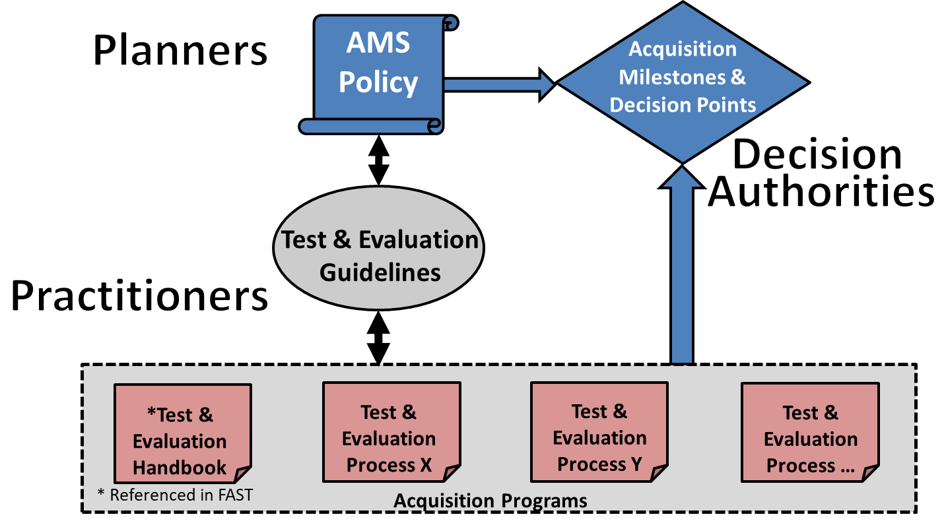
Figure 1-1: Link from T&E Policy to T&E Processes
T&E is an essential element of V&V as depicted on the left and right side of the V-Model, in Figure 1-2, T&E Application of the V-Model. This document provides a basis for test planning, conduct, and reporting in FAA Solution Implementation (SI) and In-Service Management (ISM) initiatives.
Figure 1-2: T&E Application of the V-Model
This document guides the development and maintenance of T&E processes that support AMS policy by providing information to acquisition planners and T&E practitioners and sets the objectives for T&E activities. It is the basis for the development of structured T&E processes for FAA organizations that adhere to the following 10 fundamental practices (cited in the T&E Handbook) essential for quality T&E:
- T&E activities are involved in all AMS lifecycle management phases to support and plan for the V&V of products, systems, services, capabilities, and associated work products defined in the FAA AMS Lifecycle Verification and Validation Guidelines.
- T&E activities are systematic and progressive in that they build in complexity by first focusing on testing basic components and then expanding to more complex and integrated testing.
- Every T&E program has one or more individuals accountable for the following:
  - Conduct and coordination of test activities
  - Overall quality of testing
  - Accepting and reporting test results
- T&E activities that support acceptance of work products or approval of program milestones are well defined and tracked.
- T&E programs include the following typical elements:
  - Test Teams that have a thorough understanding of program requirements and the knowledge, skills, and training for evaluating the product, system or service under test.
  - Documented test plans, procedures, and reports are comprehensive, clear, concise, objective, written in plain language, peer-reviewed, and have incorporated end user input.
  - Stable, accredited and configuration-managed test capabilities that enable the test cases to meet documented test objectives without numerous or significant deviations.
  - A complete end-to-end dry run of procedures prior to the final execution of procedures.
  - Accurately documented as-run test procedures and test logs for dry runs and final test runs.
  - Reports that provide historical test data, results, risks, deficiencies, and recommendations with clear analysis of actual performance and limitations against planned objectives and requirements.
  - Integration and testing in an end-state environment.
- Prior to requirements approval, T&E personnel participate in reviews to ensure all product, system, or service requirements are testable and validated against the operational mission.
- T&E personnel are involved in procurement-package development and source-selection process to ensure the resultant contract complies with the test strategy and scope documented in acquisition planning and test strategy documents.
- An integrated test plan [i.e., Test and Evaluation Master Plan (TEMP)] is developed and completed early in the product, system, or service lifecycle, and is routinely updated to reflect the evolution of the investment initiative.
- Operational Testing (OT) is executed in a test environment (hardware, software, interfaces, etc.) representative of the expected in-service operational conditions. OT is conducted with a representative team of end users who are expected to interface with or operate the product, system, or service under test.
- Required modifications for defects are verified and validated under conditions equivalent to those that existed when the defects were identified initially. Regression testing is conducted to verify and validate that fixes and modifications correct identified defects and do not adversely affect other interrelated operations and functionality.

Page intentionally left blank

AMS LIFECYCLE MANAGEMENT PROCESS
This section summarizes the AMS lifecycle management process and describes the major T&E functions in each of the following AMS lifecycle phases:
- Service Analysis and Strategic Planning (SASP)
- Concept & Requirements Definition (CRD)
- Investment Analysis (IA) consisting of Initial Investment Analysis (IIA) and Final Investment Analysis (FIA)
- Solution Implementation (SI)
- In-Service Management (ISM)
The typical T&E approach from SASP through ISM is illustrated in Figure 2-1, Typical T&E Approach throughout the AMS Lifecycle.
The diagram depicts the AMS lifecycle phases starting with SASP and continuing through CRD, IA, SI and ISM. The diagram identifies the key decisions, milestones, major test efforts, technical reviews, and most importantly, major T&E work products and when they would be required relative to each AMS lifecycle phase. The test activities depicted in the ISM phase provide a typical approach that may vary depending on the T&E process followed by a particular service-level engineering organization.
Through delegation from the Joint Resources Council (JRC), the Operations Governance Board (OGB) becomes the Investment Decision-making Authority for Mission Support Ops-Funded capital acquisitions. The following phases, which differ from the standard AMS lifecycle phases, constitute the lifecycle path for Mission Support Ops Funded Capital Investments:
- Need Analysis
- Alternative Analysis
- Solution Development
- Development
- Operations and Retirement
Section 3.0 details the individual elements of test planning, conduct, and reporting applicable to Mission Support Operations T&E.

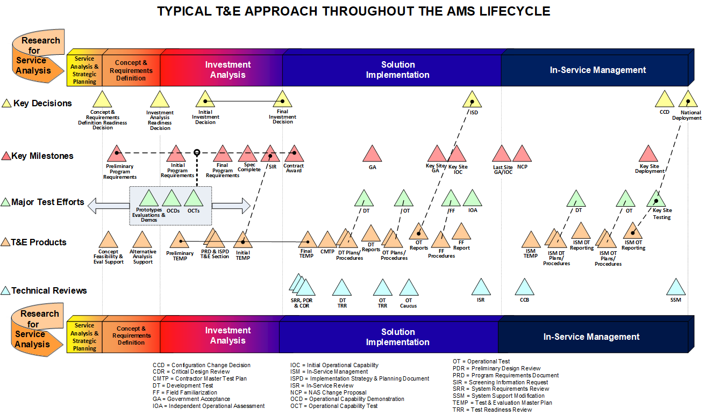
Figure 2-1: Typical T&E Approach throughout the AMS Lifecycle

Figure 2-2, V&V for Decision Support, identifies the work products (shown in light blue) required in support of major milestone decisions (shown in gold) during the AMS lifecycle and T&E test efforts during SI and ISM (shown in light green). Items depicted represent deliverables and products that are verified and validated in support of the acquisition.
The following sections provide an overview of T&E’s role in support of each phase of the FAA’s AMS lifecycle.

Test and Evaluation Support of Service Analysis and Strategic Planning/Concept & Requirements Definition
T&E support to SASP and CRD generally consists of early evaluations performed in support of concept feasibility determinations and analysis of alternative solutions. Early evaluations may be used throughout the investment planning process (i.e., during SASP, CRD, and IA) to minimize investment risks. Early evaluations include the following:
- Prototype tests
- User demonstrations
- Studies
- Modeling
- Simulations
- Proof-of-concept tests
- Operational Capability Demonstrations (OCDs)
- Operational Capability Tests (OCTs)
Prototype tests, user demonstrations, studies, modeling, and simulations are used to support system engineering processes in developing requirements, evaluating operational concepts (including human factors), and selecting technologies. OCDs and OCTs provide functional and performance information to investment decision-makers to support selection from among candidate solutions.
These evaluations may be conducted on functionally equivalent prototypes or on early development items and may be used to provide field personnel with early exposure to new products, systems, services, or capabilities under development. The focus is to identify flaws or enhancements before committing to the final investment decision to acquire production products, systems, services, or capabilities (i.e., when it is least costly to implement corrective measures or improvements). Information from early evaluations is used to develop work products for the following:
- Evaluation of operational concepts
- Support of alternative analysis decisions
- Development of requirements for the preliminary Program Requirements Document (PRD)

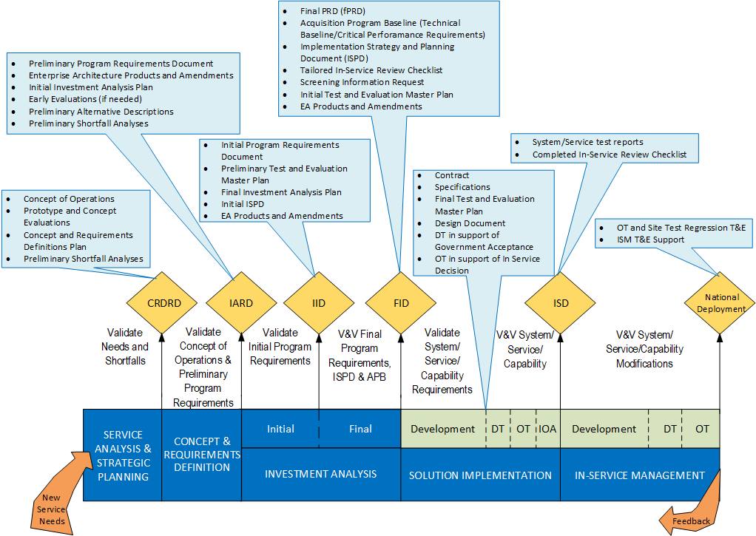
Figure 2-2: V&V for Decision Support
In keeping with best practices, early evaluations should adhere to the same fundamental T&E practices described in Section 3. Early evaluations may result in changes to product specifications, Commercial Off-the-Shelf (COTS) hardware or software, operational requirements, or vendor selections. These evaluations can also provide information for the focus of future test activities. Applying the common elements for performing quality test and evaluation described in Section 3 during these evaluations ensures that an effective and affordable T&E effort is implemented and enables the FAA to make informed decisions.

Test and Evaluation Support of Investment Analysis
T&E support to IA consists of T&E planning implemented in the following documents:
- Program Requirements Document – defines the operational framework and performance baseline for an investment program. It is the basis for evaluating the readiness of resultant products, systems, services, and capabilities to become operational.
- Test and Evaluation Master Plan – is the primary test management document for the investment program throughout its lifecycle from IIA through ISM. It describes the baseline test strategy and the scope of a test program.
- Implementation Strategy and Planning Document (ISPD) – conveys critical, relevant, and meaningful planning information to the JRC as a basis for investment decision-making. The ISPD integrates all aspects of planning for solution implementation and in-service management of a proposed investment program.
- System Specification – describes the physical, functional, and performance requirements of a product, system, or service to be obtained from a developer and contains verifiable criteria for determining whether requirements are met.
- Screening Information Request (SIR) – defines the specific efforts the developer will provide. The FAA procures products, systems, services, or capabilities from developers using agreements defined in contracts. Before selecting a developer to provide the product, system, service, or capability, the FAA issues the SIR.
Additionally, T&E support during this phase may include the continuation of early evaluations begun during SASP and CRD (see Section 2.1) or the initiation of evaluations in support of IA decision milestones.

Program Requirements Document Support
T&E support of the PRD begins during IIA and consists of developing the initial PRD in support of the Initial Investment Decision (IID) and culminates with the final PRD in support of the Final Investment Decision (FID).
T&E support for the development of PRD includes the following:
- Participating in product engineering and implementation reviews
- Ensuring all new or modified requirements for products, systems, services, or capabilities are defined and address the operational mission
- Ensuring all interfaces with the National Airspace System (NAS) operational mission are defined
- Reviewing and commenting on the testability of requirements (Requirements must be precisely defined and leave no room for subjective interpretation. Parameters and thresholds must be measurable. Functional performance requirements must be verifiable and expressed in unambiguous terms.)
- Verifying that Critical Operational Issues (COIs) are completely described, are operational in nature, represent observable events, and are testable
- Verifying that program requirements essential to meeting the service need are identified as Critical Performance Requirements (CPRs)
- Structuring the test program to address all system or subsystem components and interfaces by:
  - Defining potential test strategies and seeking feedback from engineering and implementation teams
  - Providing test strategy briefings to the Program Office, as required
  - Writing the T&E section of the PRD to require Operational and Development testing

Test and Evaluation Master Plan
The TEMP is a key work product developed by the T&E Team. The preliminary TEMP is developed during IIA in support of the IID and the initial TEMP is developed during FIA in support of the FID. The final TEMP is developed during SI (refer to Section 2.3).
The TEMP accomplishes the following objectives to ensure a comprehensive test program:
- Provides a structure for managing the T&E effort by establishing a test plan baseline that addresses all required test activities
- Establishes consensus on the scope of testing required to thoroughly and efficiently evaluate the product, system, or service (including test strategies and evaluation methods)
- Identifies proposed product, system, or service requirements to be verified and validated
- Provides traceability of program requirements and COIs to test phases in a Verification Requirements Traceability Matrix (VRTM), which includes the decomposition of COIs to MOEs, MOSs, and MOPs
- Defines a logical schedule of T&E activities in support of major investment decisions
- Specifies equipment and resource requirements to support testing
- Specifies T&E roles, responsibilities, and related training requirements
- Provides an approach for specialized evaluation areas (for example, human factors, security, and safety)
- Identifies test tools and capabilities that require development and accreditation
- Baselines test limitations and their respective impacts on evaluation elements
- Determines how the results of testing will be reported and establishes discrepancy/problem reporting methods

Implementation Strategy and Planning Document Support
T&E supports the development of the final ISPD in support of the FID. The T&E section of the final ISPD includes the following:
- Definition of test strategy and how it provides information to those responsible for key programmatic decisions
- Description of the elements of test planning and how they will be expanded and implemented via the TEMP and test plans for each major test phase
- Description of the test conduct to include activities for each phase that will be conducted by both the developer and the FAA
- Description of program test reporting

System Specification Support
T&E supports the development of the System Specification during the FIA. The T&E support of the System Specification includes the following:
- Ensuring requirements are well defined, are testable, and address operational requirements
- Ensuring consistency and traceability with operational requirements in the PRD
- Ensuring all critical interfaces are defined
- Developing verification section consistent with the TEMP

SIR Support
T&E supports the development of the SIR during the FIA. The T&E support of the SIR includes the following:
- Reviewing and commenting on instructions, conditions and notices
- Developing the T&E sections of the Statement of Work (SOW)/Performance Work Statement (PWS)/Statement of Objectives (SOO) to accomplish the following goals:
  - Describe the T&E events and activities to be accomplished by the developer that reflect T&E strategy described in the TEMP and ISPD
  - Specify the T&E elements critical for program success
  - Ensure the FAA has access to developer data, test activities, and results
  - Ensure FAA review and approval of developer deliverables such as test plans, procedures and reports
  - Describe developer T&E support required for FAA testing

Proposal Evaluation Support
For competitive solicitations, T&E evaluates the proposals for technical content against technical evaluation criteria specified in the source evaluation plan. For noncompetitive proposals (sole source procurements and Engineering Change Proposals), T&E assists in the evaluation of proposed costs as well as the technical content of the proposal.

Test and Evaluation Support of Solution Implementation
T&E support during SI of the product, system, service, or capability primarily focuses on Development Testing (DT) and OT. DT demonstrates whether all specified functional and performance requirements are met as the basis for Government Acceptance (GA). OT assesses operational effectiveness and operational suitability in support of the In-Service Decision (ISD). During SI, the final TEMP is developed by updating the Initial TEMP with information from the current program plans, solution design, and requirements.

Development Testing
DT demonstrates whether all specified functional and performance requirements are met as the basis for GA. The developer performs DT, which is witnessed by the Government Test Team. These test activities can be conducted at the developer’s facilities, the FAA William J. Hughes Technical Center (WJHTC), the Mike Monroney Aeronautical Center, and/or FAA field sites. Section 3.0 details the individual elements of test planning, conduct, and reporting applicable to DT.
The following items define typical test activities (which are tailorable based on program needs) for DT:
- DT Software Testing: Addresses new and modified software requirements decomposed from the System Specification
- DT Hardware Testing: Addresses new and modified hardware requirements decomposed from the System Specification
- Factory Acceptance Testing: Verifies that hardware, firmware, and COTS/Non-Developmental Item (NDI) subsystem components satisfy allocated requirements
- Functional Qualification Testing: Verifies that requirements imposed on a vendor or subcontractor under contract to the prime developer for delivery of a product or subsystem which demonstrates capabilities to integrate with the NAS through the use of drivers and simulators
- DT Installation and Integration Testing: Verifies the proper installation and functioning of the complete product, system, or service in the laboratory environment
- DT System Testing: Verifies that integrated software and hardware components satisfy System Specification requirements under conditions that emulate the projected operational conditions and configurations
- Production Acceptance Testing: Verifies that production line units are built according to contract specifications prior to installations at field sites
- Site Acceptance Testing (SAT): Verifies that installed hardware and software components satisfy contract requirements for GA at each site
- DT Regression Testing: Verifies that integrated software and hardware components satisfy contract requirements after making changes based on anomalies discovered during previous DT activities. DT Regression Testing also ensures that changes do not inadvertently result in a problem elsewhere in the product, system, or service
The typical relationships of the aforementioned nine DT activities are depicted in Figure 2-3, DT Activity Structure.
The typical flow of DT activities may be tailored for individual programs so that some activities may be performed in parallel or in multiple phases of implementation. For programs that replace the traditional development cycle with an iterative method known as “Agile Development” or “Agile Acquisition,” these DT test activities may need to be tailored accordingly.

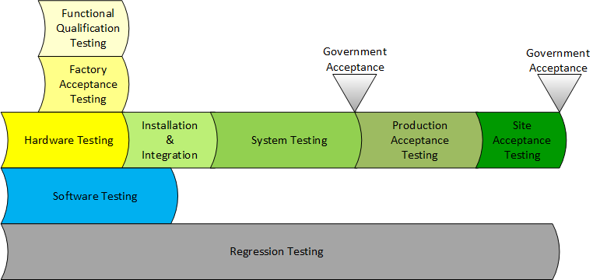
Figure 2-3: DT Activity Structure

Operational Testing
OT supports the assessment of operational readiness by evaluating the effectiveness and suitability of systems, services, and products prior to ISD. The CPRs and COIs for the investment program are defined in the PRD. These CPRs and COIs are critical requirements and operational objectives that must be examined during OT to determine operational readiness to achieve investment objectives. COIs are stated in the form of a question at a high level and usually cannot be answered directly from a single test or measurement. Each COI must be broken down into Measures of Effectiveness (MOEs) and Measures of Suitability (MOSs). CPRs are a subset of the overall PRD requirements and represent attributes or characteristics considered essential to meeting the needs that the investment program is seeking to satisfy. MOEs and MOSs are linked to Measures of Performance (MOPs), CPRs, and other program requirements to provide objective measures for OT test cases that evaluate operational effectiveness and suitability. Figure 2-4, Decomposition of Critical Operation Issues to Test Cases, illustrates the decomposition of COIs down to test cases in support of the operational readiness assessment. Section 3.0 details the individual elements of test planning, conduct, and reporting applicable to OT.
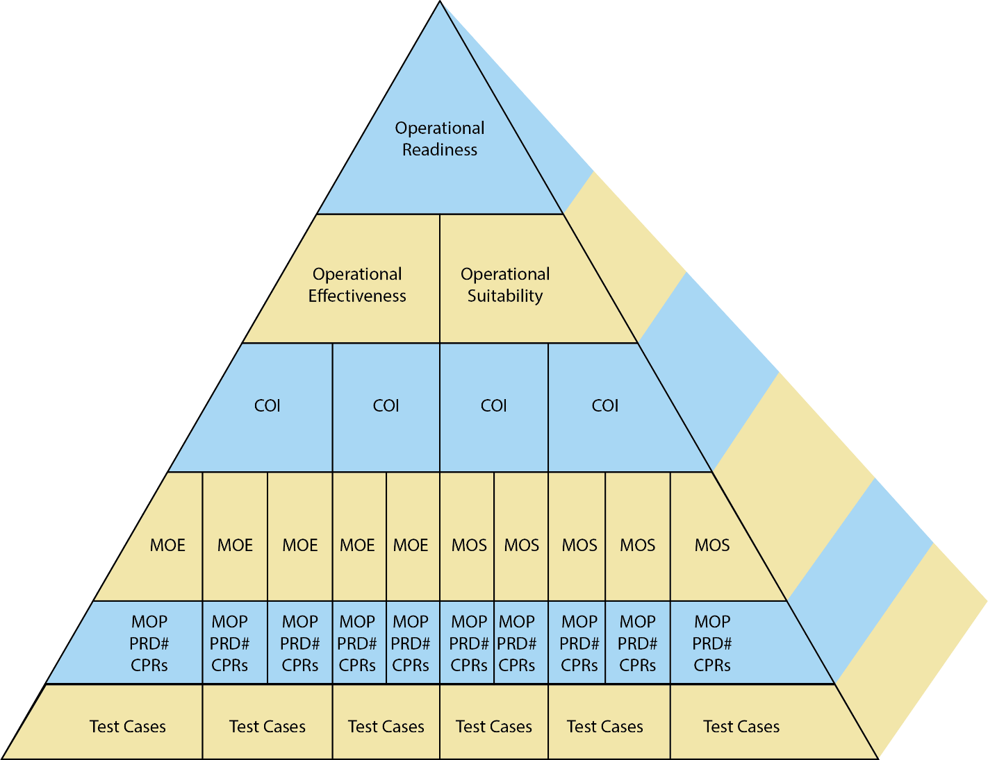
Figure 2-4: Decomposition of Critical Operation Issues to Test Cases
The following evaluation areas (which may be modified based on program needs) are addressed during OT:
- NAS integration testing for
      - Functional verification
      - Regression of DT in new environment
      - Interoperability and Interfacing
      - Stability
      - Operational load
- Operational effectiveness and suitability testing
      - Reliability
      - Maintainability
      - Availability
      - Supportability
      - Transportability
      - Logistics
      - Degraded operations
      - Stress and NAS load testing of all interoperable subsystems
      - Performance
      - Human Factors evaluations
      - Safety requirements validation and testing to identify new safety hazards
      - Security
      - Site adaptation
      - Transition and switchover/fallback
      - Certification criteria
      - Personnel
      - Training

Field Familiarization
Site Field Familiarization (FF) is the responsibility of facility personnel at each operational site and is the final activity required to achieve facility Initial Operating Capability (IOC). Its main focus is to familiarize field users, rather than provide formal system verification or validation of the fielded product, system, or service. If requested by the Program Management Office, the test organization provides support services for FF, including the development of plans, procedures, and briefing materials.

Independent Operational Assessments
An Independent Operational Assessment (IOA) is conducted on FAA products, systems, services, and capabilities that have been designated by the Vice President of Safety and Technical Training. IOAs are conducted in an operational environment to confirm that these solutions are operationally effective, suitable, and safe before they are incorporated into the NAS. IOAs are conducted after declaration of IOC and prior to the deployment decision (such as an ISD). For designated programs, an IOA report must be completed to support the deployment decision.
Air Traffic Organization Safety and Technical Training manages all aspects of IOA in accordance with the IOA Technical Process. These include the development of IOA plans and procedures, obtaining subject matter experts to form the IOA Team, conduct of the IOA, and coordination with stakeholders.
The IOA Team develops plans and procedures that are based on the decomposition of the COIs defined in the program requirements document. The IOA Team members also familiarize themselves with the test program, including the TEMP and test plans and procedures. To maintain independence, the IOA Team does not directly participate in the testing of designated programs. The team monitors and observes portions of DT, OT, SAT, and FF to:
- Obtain data that will not be available during IOA conduct
- Identify safety and operational concerns early in the process
- Gain familiarity with the solution
Based on observations of the OT and site testing, the IOA Team may develop a Pre-IOA Status Paper detailing any significant concerns prior to the IOA. The IOA Team also reviews the test reports or results, particularly the OT reports.
Once acquisition test activities are complete and the product, system, service, or capability is operational at the key site(s), the readiness of the solution to begin IOA is declared in writing via the IOA Readiness Declaration from the Vice President of the acquisition organization to the Vice President of Safety and Technical Training. During IOA conduct, the IOA Team collects operational data to support the COIs by focusing on the operational use and maintenance of the solution. These data typically include observations of live operations, input from users, and system and facility data. The IOA Team produces an IOA report, which includes identified safety hazards and operational concerns as well as an independent determination of operational readiness.

Test and Evaluation Support of In-Service Management
In accordance with the AMS, the ISM phase starts after the final site installation, GA and IOC. The primary goal of ISM is to support products, systems, services, and capabilities to ensure they are operated, maintained, secured, and sustained in real time to provide the level of service required by users and customers. In addition, fielded products, systems, services, and capabilities receive periodic monitoring and evaluation, and performance data is provided to ongoing analysis activities for revalidating the need to sustain deployed assets or to take other action to improve service delivery. To support continuous operation after ISD, the ISM organizations:
- Implement Pre-Planned Product Improvements (P³Is) or block upgrades as stipulated at FID
- Monitor performance and customer expectations
- Sustain products, systems, services, and capabilities to address the operational needs
- Enhance and correct fielded product, system, service, and capability as identified in operational site-generated change requests and problem reports
- Upgrade and perform technical refresh of fielded products, systems, services, and capabilities as needed
- Dispose of assets at end of service life when no longer needed
ISM testing continually verifies functional requirements and problem resolution of operational products, systems, services, and capabilities. ISM testing also validates the safety, suitability, and effectiveness of operational assets.

In-Service Management Test and Evaluation Master Plans
The TEMP for ISM can be used to define and document the baseline test strategy, evaluation approach, and test events needed during continuous in-service modifications. Any additional specific test events and associated test activities required for an individual deployment will be described in associated ISM planning documents and release deployment test plans. The TEMP should be revised when the product, system, service, or capability baseline requires a change in the test strategy, or the ISM approach is significantly changed or restructured.

In-Service Management Developmental, Operational, and Key-Site Testing
During ISM, FAA products, systems, services, or capabilities may be modified through authorization transmitted by a System Support Directive (SSD). The SSD takes on the forms of either a System Support Modification, System Technical Release, or a System Documentation Release. Development, operational, and site testing are performed to ensure changes made to the products, systems, services, or capabilities are correctly implemented and operationally ready. These tests are performed in accordance with documented and structured test processes defined by each ISM organization in accordance with FAA Orders and AMS Policy guidance. This applies to development and implementation of all NAS and Mission Support modifications during the ISM lifecycle phase. ISM test processes include standard test approaches that define the detailed activities to be included during testing. These processes also support and ensure that safety risk management and information system security requirements are addressed.
ISM DT verifies elements of the product, system, service, or capability related to specific requirements or functionality changes and is performed by the developer. If the developer is other than the FAA, ISM DT is witnessed by the FAA Test Team. ISM DT also verifies that hardware and software fixes address documented discrepancies and problem reports.
ISM OT determines the operational suitability and effectiveness of the modified product, system, service, or capability and is performed by the FAA Test Team. This is accomplished by validating the requirements and functionality of the product, system, service, or capability with field personnel utilizing operationally realistic configurations, data, and scenarios. Regression testing is also conducted to verify the integrity of the modification and fixes. Additionally, regression testing is performed to ensure the changes have not introduced any new problems or issues, and to support validation of the system’s readiness for operational use.
Key Site testing is conducted at one or more operational facilities to verify system performance and to ensure the system is ready for installation at the remaining operational sites.

COMMON ELEMENTS FOR PERFORMING TEST and EVALUATION
This section discusses elements that are common across all types of T&E throughout the lifecycle of products, systems, services, or capabilities. These elements are implemented independent of the size of the product, system, service, or capability, or the complexity of the test. The three areas to be discussed in this section are test planning, test conduct, and test reporting.

Test Planning
Test planning is the initial step in T&E to ensure all essential elements required for a successful test are in place. This provides test personnel with a structured approach to the design and execution of all aspects of the test.

Overall Test Approach
The overall test approach is dependent on complexity of the product, system, or service, the test(s) to be conducted, the phase of the AMS lifecycle, and whether the strategy addresses a specific test or series of tests during the development of a new product, system, or service upgrade. Every test approach describes the necessary planning activities required for testing, the necessary elements for the conduct of testing, and the test reporting activities required to document testing results. Finally, the 10 fundamental practices for quality T&E listed in Section 1 should be incorporated to ensure a well-structured and complete overall test approach.

Develop Applicable Test Plans
The test plan describes the planning and preparation activities required before conducting testing. It describes how testing will be accomplished, how test procedures will be executed, and how test results will be reported. It provides sufficient detail to guide the development of test procedures.
A test plan contains the following key elements:
- Test program management
- Identification and descriptions of tests to be conducted (providing enough detail so that test procedures can be written based on these test descriptions)
- Test environments, tools, and facilities
- Schedule
- Discrepancy reporting, categorization, and corrective action process
- Configuration Management (CM)
- Accreditation plans for test capabilities
- Requirements tracking through appropriate VRTM
- Test limitations
- Test reporting strategy

Test Program Management
The management of individual tests and test programs adhere to the basic principles of program management. The three primary elements continuously managed and evaluated are schedule, cost, and technical requirements. These are particularly important for test programs to ensure the test approach and management are consistent with overall program management goals and objectives. Test management and personnel should be aware of schedule, cost, and technical requirements to weigh the need to modify the test approach to address changes that develop in any or all of these primary elements.

Define Entrance and Exit Criteria
Before starting a test activity, entrance criteria are identified and documented. Entrance criteria provide an objective measurement of what needs to be in place, with all dependencies clearly identified. At the completion of the test activity, exit criteria provide objective measurements of what each activity has accomplished, ensuring an orderly progression of activities and demonstrating that product, system, or service maturity is increasing toward a successful acceptance of the product, system, or service. For major tests such as DT and OT, the clear definition of entrance and exit criteria is essential to ensuring all aspects of these tests are thoroughly addressed and completed.
Examples of generic entrance and exit criteria are as follows:
Entrance Criteria:
- Exit criteria are identified and documented as part of the entrance criteria
- All entrance criteria as defined in the approved test plans are satisfied
- All test plans have been submitted, reviewed, and approved
- Test procedures have been submitted, reviewed, and approved
- The test configuration is known and documented
- All equipment and software required by test plans and procedures have been installed and are available
- Dry run testing has been completed
- The configuration under test does not have known deficiencies which would affect the functions to be verified by test
- If required, a Test Readiness Review (TRR) has been conducted
- If required, test capability accreditation has been conducted and approved
Exit Criteria:
- All exit criteria as defined in the approved test plan(s) are satisfied
- Completion of all testing in accordance with approved test plans and test procedures
- All post-test reviews are complete
- Test results are documented and accepted by the appropriate authorities
- All discrepancies are fully documented, assessed, and status reported
- All requirements are thoroughly addressed
- All required regression testing has been successfully completed

Test Program Schedule
Test program schedule and resources are derived from and based on test design and associated program constraints. Test program schedule and resources can be impacted by program constraints, which should be identified using the Risk Management process defined in the NAS Systems Engineering Manual (SEM). The Test Team can draw on historical data from test programs of equivalent complexity and risk to develop the test design for a program. Historical data may be used also to assess T&E tasks to establish durations and resource estimates. Initial test schedule milestones and completion dates are developed by linking them to key program milestones and acquisition decision points. The test schedule is refined further by defining T&E tasks for each test milestone and completion date. Finally, test schedule dependencies are established by linking all associated T&E tasks, as well as other program milestones and completion dates that relate to T&E tasks. This final schedule becomes the test program baseline.

Develop and Maintain a Verification Requirements Traceability Matrix
The FAA SEM defines a VRTM as a “matrix correlating requirements and the associated verification method(s). The VRTM defines how each requirement (functional, performance, and design) is to be verified, the stage in which verification is to occur, and the applicable verification method levels.” The VRTM provides the ability to trace a lower-level requirement back to its source, or “parent requirement,” and to maintain status of requirement verification. The VRTM provides testers with a comprehensive summary of all requirements to be tested and how each will be verified. Typically, it includes the following:
- A specific requirement identifier
- A short description of the requirement
- Identification of the verification method that will be used to show that each requirement is satisfied through demonstration, test, analysis, or inspection
- Specific test activity that will be used to verify the requirement
Development of the VRTM is an iterative process. During early development, the TEMP VRTM is generated with a mapping of COIs/MOEs/MOSs/MOPs and program requirements from the PRD. The developer then creates a DT VRTM that maps DT requirements from the System Specification to DT activities. During OT Test Plan development, the TEMP VRTM provides the basis for the OT VRTM, which is further refined to include COIs/MOEs/MOSs/MOPs and program requirement mapping to individual OT test cases.

Test Capabilities
Test capabilities are assets used in conjunction with the product, system, or service under test or a representation of the product, system, or service that enable generation of data that address test measures. Test capabilities include the following examples:
- Testbed – A stand-alone or distributed environment created for testing purposes. It may consist of a combination of specialized hardware, software, interfaces, and real or simulated environmental conditions.
- Simulated environments include the following:
  - Simulation Files (Scenarios/Scripts) – Used to automate procedures, system load, specific complex situations, etc.
  - Simulated Interfaces – Typically, one or more interfaces are simulated when live data or other product, system, or service interfaces are not available or practical.
- Instrumentation and Test Tools – Equipment items that include data collection and analysis tools, drivers, oscilloscopes, meters, analyzers, and probes. Instrumentation and test tools may be COTS or developmental items.
- Modeling – A physical, mathematical, or otherwise logical representation of a system, entity, or process. Typically, modeling is used to test and evaluate future real-world capabilities without actually implementing them.
- Live Interfaces – One (or more) live data feeds are available to interface with the product, system, service, or capability in the test environment.
Required test capabilities are identified, developed, and accredited to verify and validate the capability is acceptable for a specific testing purpose, maintained, and managed. This ensures all test assets are in place and accredited prior to the start of test activities to enable a thorough and complete evaluation of the product, system, service, or capability according to the test objectives.

Test Personnel Resources
The T&E Team develops and executes the test project. A typical T&E Team is comprised of a T&E Manager, DT and OT Test Directors, Test Leads, and Test Team personnel. Their responsibilities are as follows:
- The T&E Manager directs and manages T&E Teams within their organization.
- The DT Test Director is responsible for the overall planning and completion of DT.
- The OT Test Director is responsible for the overall planning and completion of OT.
- The Test Lead is the technical lead for assigned test activities.
- The Test Team personnel develop and conduct each phase of a test program.
- Subject Matter Experts support the planning, development, and conduct of testing.
Based on project size and scope, team member positions may be combined.

Develop Test Procedures
Test Procedures include all of the details for conducting a particular test to verify requirements as specified in the respective Test Plan(s). These details include the following:
- Tables of step-by-step instructions to run the test
- Observations to be made during the test including questionnaires for site personnel to fill out
- Expected results, including success criteria
- Objectives
- Test limitations
- Government Furnished Equipment (GFE), Government Furnished Information (GFI), and Government Furnished Property (GFP) required for the specific test
- Notations of the requirements being tested by a particular test and step
- Data collection, reduction, and analysis required
- Test tools and equipment required
- Configuration of the product, system, or service under test and the test environment

Problem Reporting
The developer establishes and maintains a database for submitting, tracking, reporting, and maintaining Program Trouble Reports (PTRs). The database supports the FAA’s awareness of problems from initiation to final corrective action and archiving. The database enables status reporting of all test problems. The developer uses the database for tracking problems associated with any system, equipment, software, or firmware placed under formal configuration control. The FAA reviews the overall design of the database to ensure operational use and functionality. The developer provides FAA personnel with access to the database and provides reports requested by the FAA. In addition, the FAA develops and maintains a database for submitting, tracking, reporting, and maintaining Discrepancy Reports (DRs) initiated as a result of FAA testing. The FAA may also enter issues/PTRs into the developer’s database depending on the stage of the lifecycle. All DRs that require corrective action by the developer are raised to PTR status.

Test Conduct
The following are the major elements of each test conduct:
- Debug and Dry Run Testing
- Pre-Test Briefings
- Final Test Execution
- Post-Test Reviews
- Regression Testing

Debug and Dry-Run Testing
Prior to final execution of DT and OT, debug and dry run testing of the procedures is performed. Debug testing evaluates test procedures against the product, system, or service under test to ensure that the test steps are correct, complete, and produce repeatable expected results. During this testing, the procedures are refined and updated to provide a logical flow to the sequence of test steps.
Dry runs are a complete end-to-end execution of test procedures using final test execution configurations and accredited test capabilities to determine the following:
- The laboratory environment is prepared.
- The product, system, or service is properly installed and configured.
- The product, system, or service has the correct versions of both software, firmware, and adaptation available, and all system parameters that need to be set have been identified.
- Procedures are mature and red-line text changes are fully incorporated (i.e., test procedures can be run start to finish, as documented, without major deviations or anomalies).

Pre-Test Review
Before each DT and OT test, a pre-test review is conducted to ensure readiness to begin the respective test. A typical pre-test review covers the following items, which can be tailored according to the complexity of the product, system, or service:
- Test objectives and success criteria in accordance with the approved Test Plan and Test Procedures
- Proposed procedure changes (redlines)
- Test configuration definition
- Test personnel assignments
- Test conduct walkthrough
- Results of the CM audit
- Test limitations
- Review of known product, system, or service anomalies and workarounds that might impact testing
- Planned deviations
- Data Reduction and Analysis (DR&A) methods

Final Test Execution
The standard activities for final test execution include the following:
- Proper test configuration is verified before starting test execution (including hardware, software, firmware, adaptation parameters, test equipment, and test tools).
- The test team executes test procedures and documents deviations and changes.
- A Test Status Report is prepared for each test run.
- The test team ensures anomalies are properly documented (at the time of occurrence) in the test log.
- The “as-run procedures” (i.e., with mark-ups) and test log is provided after test completion.
- A walkthrough review of the DR&A results of test data is performed to verify requirements.
Test observer logs capture issues that impact operational effectiveness or suitability. If questionnaires are used to capture qualitative and quantitative data, they are completed and collected immediately following the test execution. The Test Lead also maintains a list of anomalies that identify all issues encountered during testing.

Post-Test Reviews
Test personnel conduct a Post-Test Review for each test performed during DT and OT to confirm test results and completion. A typical Post-Test Review covers the following items, which can be tailored according to the complexity of the product, system, or service:
- Overall test results, including a summary of all associated requirements
- Status of test objectives and exit criteria as specified in the associated Test Plan and Test Procedures
- Test conduct details (for example, start date and time, stop date and time, etc.)
- Any test configuration changes since the Pre-Test Briefing
- All problems encountered, including where and how they are documented
- Descriptions of all deviations and anomalies encountered
- Test procedure changes
- Details on any failed steps and requirements
- Review of Failure Reporting and Analysis results and walkthrough findings
- Regression test recommendations
- Documentation of outstanding test issues with action plans for closure

Regression Testing
During testing, changes made to software or hardware requires regression testing. Regression testing verifies the integrity of solutions to anomalies. Additionally, performing regression testing ensures these solutions do not introduce any new problems or issues. Regression testing also supports validation of the product, system, or service’s readiness for operational use. Regression testing may require the participation of site personnel.

Test Reporting
This section addresses the three major types of test reporting that include:
- Early Evaluation Reporting
- Preliminary Reporting
- Final Reporting

Early Evaluation Reporting
Prototype tests, user demonstrations, studies, modeling, and simulations support system engineering processes in developing requirements, evaluating operational concepts (including human factors), and selecting technologies. OCDs and OCTs provide functional and performance information to the project office, to support selection from among candidate solutions.
These evaluations may be conducted on functionally equivalent prototypes or on early development products, systems, services, or capabilities and may be used to provide field personnel with early exposure to new products, systems, services, or capabilities under development. The purpose of early evaluations is to:
- Support System Engineering processes
  - Development of PRD requirements
  - Evaluation of operational concepts
  - Selection of technologies
- Provide a means of analysis of alternate solutions
- Minimize program risk

Preliminary Reporting
The following subsections detail reports that may precede final reporting.

Interim Assessment Report
The OT Interim Assessment Report (IAR) is an optional reporting mechanism that provides management with an assessment of the current state and maturity of the product, system, or service by identifying capabilities and limitations as tested for that reporting period. OT IARs are developed following specific milestones, whether issues exist or not, as defined in the TEMP.
The OT IAR provides sufficient data to support resolution plans and program decisions. Additionally, the OT IAR assists in planning future test activities and support planning for product, system, or service implementation and deployment. Specifically, the OT IAR:
- Provides the status of critical performance criteria defined in the TEMP
- Analyzes issues based on their impact on COIs and CPRs
- Provides early operational reporting for:
  - DT
  - Early operational evaluations
  - Final execution of OT
- Highlights critical product, system, or service issues which may impact the following operational milestones:
  - IOC
  - ISD
  - Operational Readiness Decisions (ORDs) at field sites
- Provides support for programmatic decision-making (including scheduling, test planning, site deployment, and site acceptance testing)
- Supports operations and maintenance planning
- Provides input to the OT Quicklook Test Report and OT Final Test Report
Following the completion of final execution of OT, the OT Quicklook Test Report is developed to provide a preliminary assessment of operational readiness. This report is provided in advance of the more detailed Final Test Report, which requires more analysis and time to complete. The report contains preliminary results and is not intended to support major programmatic or operational milestone decisions.

Quicklook Report
The OT Quicklook Test Report documents preliminary results of all final execution of testing and the resolution plans for any issues discussed at an OT Close-out meeting or Caucus, which is conducted to present and review all findings and test results related to operational effectiveness and suitability of the product, system, or service. It expands upon the content provided through an OT summary report or minutes, which is produced to document the status of each COI, MOE, MOS, MOP, and CPR for the product, system, or service under test. General descriptions of the product/system/service’s performance and functional and operational limitations are included in the Quicklook Test Report. If the resolution of program issues delays delivery of the OT Final Test Report, an OT Quicklook Test Report may be required after each major OT regression test.

Final Reporting
The DT Test Report addresses test results, including test conduct, data collected, the DT DR&A process, and conclusions to be drawn from test data. The FAA utilizes results contained in the test report to verify the developer has furnished a product that conforms to all contract requirements for acceptance.
The OT Final Test Report presents specific findings related to the operational effectiveness and suitability of the product, system, or service. The report:
- Contains an executive summary of test results
- Addresses the resolution of all COIs
- Provides a determination of operational readiness of the product, system, or service (operational effectiveness and suitability)
- Characterizes the operational capabilities and limitations of the product, system, or service based on performance against the CPRs
- Documents the methods used in, and results of, detailed analyses of test data
- Identifies and assesses PTRs and issues that impact critical capabilities and benefits
- Updates the status of problems highlighted in the OT Quicklook Test Report
- Provides status of exit criteria as defined in the OT Test Plan
- Includes test descriptions, results, conclusions, and recommendations
- Identifies technical or operational risk areas
- Includes all approved deviations and waivers generated as a result of testing
Conclusions regarding operational effectiveness and suitability are based on the combined results of all operational tests. Operational readiness is determined by operational effectiveness and suitability performance in accordance with COIs and CPRs. In addition, the report addresses risks or product/system/service limitations associated with shortfalls in meeting mission needs, operational requirements, and safety requirements. The report also, identifies and assesses any new safety hazards.

Tailoring
Tailoring of individual processes may be made by organizations as long as the 10 fundamental practices for quality T&E, identified in Section 1, are evident.
To meet the unique needs of a specific test or program, T&E guidance may be tailored based on the following:
- Test or program complexity/scope
- Risks associated with the test or program
- Level of effort required to complete the evaluation
- Acquisition strategies and type (for example, COTS/NDI services; software; hardware; procurement of products, systems, services, or capabilities; modification of facilities; changes in the physical infrastructure; development of functional interfaces; spiral development implementation; etc.)
- Test strategies in the approved TEMP
Tailoring of T&E guidance can involve the following types of adjustments:
- Change in formality
- Change in frequency
- Change in format
- Modifying an element of the guidance
- Eliminating an element of the guidance
- Combining elements of the guidance
- Renaming an element of the guidance
- Changing or consolidating guidance roles and responsibilities
- Changing the order of an element of the guidance
- Modifying PTR/DR priority definitions
The following are T&E elements commonly tailored for a test or test program:
- DT activities
- Required DT developer documents
- DT problem reporting
- OT Interim Assessments Reports
- Logistics for final execution of OT conduct support
- Field Familiarization Support
- Agile development

Page intentionally left blank

APPENDIX A – ACRONYMS
AMS Acquisition Management System

CM Configuration Management
COI Critical Operational Issue
COTS Commercial Off-the-Self
CPR Critical Performance Requirement
CRD Concept and Requirements Definition

DT Development Test
DR Discrepancy Report
DR&A Data Reduction and Analysis

FAA Federal Aviation Administration
FF Field Familiarization
FIA Final Investment Analysis
FID Final Investment Decision

GA Government Acceptance
GFE Government Furnished Equipment
GFI Government Furnished Information
GFP Government Furnished Property

IA Investment Analysis
IAR Interim Assessment Report
IIA Initial Investment Analysis
IID Initial Investment Decision
IOA Independent Operational Assessment
IOC Initial Operating Capability
ISD In-Service Decision
ISM In-Service Management
ISPD Implementation Strategy and Planning Document

JRC Joint Resources Council

MOE Measure of Effectiveness
MOP Measure of Performance
MOS Measure of Suitability

NAS National Airspace System
NDI Non-Developmental Item

OCD Operational Capability Demonstration
OCT Operational Capability Test
OGB Operations Governance Board
ORD Operational Readiness Decision
OT Operational Test

P³I Pre-Planned Product Improvement
PRD Program Requirements Document
PTR Program Trouble Report
PWS Performance Work Statement

SASP Service Analysis & Strategic Planning
SAT Site Acceptance Testing
SEM Systems Engineering Manual
SI Solution Implementation
SIR Screening Information Request
SOO Statement of Objectives
SOW Statement of Work
SSD System Support Directive

T&E Test and Evaluation
TEMP Test and Evaluation Master Plan
TRR Test Readiness Review

V&V Verification and Validation
VRTM Verification Requirements Traceability Matrix

WJHTC William J. Hughes Technical Center

APPENDIX B – GLOSSARY
Accreditation | Formal certification that a test capability is acceptable for a specific application.
Adaptation | Unique site-dependent data/functions required by the operational program to provide the flexible capability necessary for individual site performance determined during implementation.
As-Run Procedures | Test procedures with developer markups documenting actual test procedures after completion.
Blue-Line Change | Change made to test procedures during final test conduct.
Dry Run | Complete end-to-end execution of test procedures using final test configurations and accredited scenarios, simulations, and/or test tools.
Critical Operational Issue | A key operational effectiveness or operational suitability issue that must be examined during operational test to determine the system’s capability to perform its mission.
Enterprise Level Capabilities | NAS Requirements that may involve more investment initiatives to implement. Changes may be required in multiple FAA assets, Air Traffic Control procedures, and avionics developed by industry. Verification and Validation of Enterprise-Level capabilities may require multiple assets to reach specified states of development and may be performed by a dedicated Enterprise-Level Capability Test Team.
Field Familiarization | Conducted at each site by AT and Tech Ops personnel to verify the site is ready to switch over to the new system.
Initial Operational Capability | IOC is the declaration by site personnel that the system is ready for conditional operational use in the NAS and denotes the end of field familiarization at that site.
Measure of Effectiveness | First-level, qualitative decomposition of an operational effectiveness component associated with a COI.
Measure of Performance | Quantitative values that characterize MOEs or MOSs. These values are measurable by a test process.
Measure of Suitability | First-level, qualitative decomposition of an operational suitability component associated with a COI.
Operational Effectiveness | The degree to which a product accomplishes its mission when used by representative personnel in the expected operational environment.
Operational Readiness | Operational readiness encompasses operational effectiveness and operational suitability. [AMS 2.6.1] Test and evaluation examines performance and operational readiness (suitability and effectiveness) in support of decision-makers at the production, deployment, and in-service decisions. [AMS 4.4.2]
Operational Readiness Date | Operational readiness is attained when site operational personnel are satisfied the solution can support full and sustained air transportation operations. The milestone occurs after completion of the joint acceptance and inspection process when the site official signs the facility log designating the new solution as the primary means for air transportation operations.
Operational Suitability | The degree to which a product intended for field use satisfies its availability, compatibility, transportability, interoperability, reliability, maintainability, safety, human factors, logistics supportability, documentation, personnel, and training requirements.
Peer Review | A written, online or real-time structured review performed by independent Subject Matter Experts or peers who perform a methodical examination of a work product to enhance document quality.
Prime Contractor | The private company or organization that has an established contract with the Government to provide a system or service. The term prime is used to differentiate from subcontractors whose contract is not directly with the Government but rather with the prime contractor.
Procedure | Subordinate to a process. A set of activities or steps taken to achieve a given purpose. Any specific combination of machines, tools, methods, materials, and/or people employed to develop a work product. Could be used by multiple persons in one group either separately, recursively, or concurrently. Some activities transform inputs into outputs needed for other activities.
Red-Line Change | Change made to test procedures during dry run conduct.
Subsystem Specification | Developed by the contractor and must show traceability to the system-level specification.
System Specification | Describes the physical, functional, and performance requirements of a product, system, or service to be obtained from a developer and contains verifiable criteria for determining whether requirements are met. The System Specification must show traceability to the PRD.
Testbed | A stand-alone or distributed environment created for testing purposes. It may consist of a combination of specialized hardware, software, real or simulated environmental conditions, and may be a component of a larger test environment.
Test Activity | A category of test hierarchy between Test Phase and Test Case Group, with an identifiable title and reporting requirements.
Test Capability | A resource or method used to verify or validate requirements. This may include testbed(s), simulations, simulated interfaces, modeling, scripts, test equipment, etc. Test capabilities must be accredited before they are used in test activities.
Test Case | A subset of test procedures that specify a) one or more product requirements to be verified and validated; b) the resources required to execute the test case; c) the specific steps that must be taken to perform the test case. Identified by paragraph number in a Test Procedures document.
Test Case Group | A collection of test cases linked by a common purpose, such as to verify a specific set of product requirements. A group may consist of a similar set of test cases, performed under a range of differing conditions. Identified by paragraph number in a Test Procedures document.
Test Category Hierarchy | Sequence of test events as defined in the TEMP that details Plans and Test Procedures activities.
Test Environment | The hardware, software, interface, and support configuration necessary to meet test objectives (for example, data, testbeds, simulators, test instrumentation, test tools, etc.)
Test Event | The conduct of a Test Activity, or portion of a Test Activity, where data is collected for the record.
Test Phase | Highest level subdivision in a test program (for example, T&E Program Planning, DT, OT).
Test Processes | A general term for methods that may be used or procedures which may be followed to conduct test.
Test Procedure | A guiding document that details the steps to be taken.
Test Program | All of the identified activities that are required to perform V&V of a NAS System or a NAS Enterprise Level Capability.
Test Scenario | Simulations or scripted input developed to exercise combinations of operational factors that influence system performance.
Test Steps | A subset of a test case that directs test personnel to perform actions, and document responses.
Test Tools | Support equipment (hardware/software) that allows the verification and validation of capabilities, functions, fixes and performance.
Validation | Confirmation that an end product or end-product component will fulfill its intended purpose and user needs when placed in its intended environment. The methods to accomplish validation are applied to selected work products as well as to the end product and end-product components. Work products should be selected on the basis of which are the best predictors of how well the end product and end-product components will satisfy the intended purpose and user needs. Validation can apply to all aspects of an end product in any of its intended environments such as operation, training, manufacturing, maintenance or support services.
Verification | Confirmation that selected work products meet their specified requirements. This includes verification of the end product (system, service, capability, or operational change) and intermediate work products against all applicable requirements. Verification is inherently an incremental process since it occurs throughout the development lifecycle of work products, beginning with initial requirements, progressing through subsequent changes, and culminating in verification of the completed end product.

